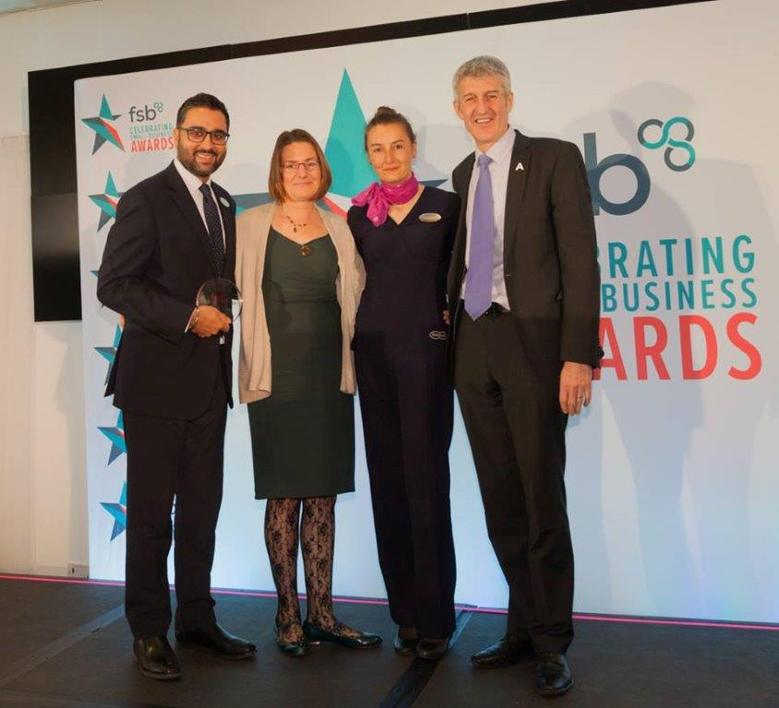



Apprenticeship Ambassador Network
What is an Apprenticeship Ambassador?
The Apprenticeship Ambassadors are all employers who have recruited apprentices as part of their workforce.
They are passionate about their experiences with apprentices and are keen to promote the apprenticeship route to other employers and potential new apprentices.
Become an Apprenticeship Ambassador
The apprenticeship reforms have encouraged lots of new and exciting businesses and sectors to be more actively involved in apprenticeships. We want our refreshed ambassador network to reflect this dynamic.
If you are interested in joining as an Ambassador, please contact: AAN.CHAIR@education.gov.uk
For more information visit: gov.uk/government/groups/apprenticeship-ambassador- network

What does an Apprenticeship Ambassador do?
Proactively champions apprenticeships in their own networks including customers, supply chains, and trade & sector bodies
Acts as a role model to promote and encourage the breadth and diversity within apprenticeships
Shares experiences, knowledge and skills and talks positively and honestly about the impact an
apprentice has made within your organisation – this may be through case studies, meetings and events and via social media
Endorses apprenticeships at job fairs, skills shows and events and influences other employers about the benefits of apprenticeships
Ambassadors volunteer to undertake their role for approximately 1 day every 3 months.
What support will an Apprenticeship Ambassador receive?
- Be part of a network of trusted and influential Apprenticeship Ambassadors locally as part of the wider region – expanding your own networking and peer to peer support opportunities
- Invited to an annual regional conference to share good practice, network across the regional ambassador group and hear topical speakers including Ministers.
- Promotion via our social media channels to support key messages and campaigns, e.g. National Apprenticeship Week; and showcasing your role, as both a significant employer and Apprenticeship Ambassador.
John Druce, L&D Manager, Arqiva and Co-Chair of the South East AAN says:
“I have been delivering apprenticeships since 2008 and they make a fantastic contribution to our business, creating a vibrant talent pipeline and providing the skills we need to meet the needs of our customers and to achieve our business goals. I am immensely
proud that 80% of our apprentices stay with us for the long term, developing and progressing their careers and demonstrating tremendous levels of loyalty and
commitment. I am always delighted to speak with other employers to highlight the benefits apprenticeships can bring their business.”
Follow National Apprenticeship Service: @Apprenticeships / @FireItUp_Apps National Apprenticeship Service
Visit apprenticeships.gov.uk / 08000 150 600

